Project-1

(Titanic Dataset Decision Tree)

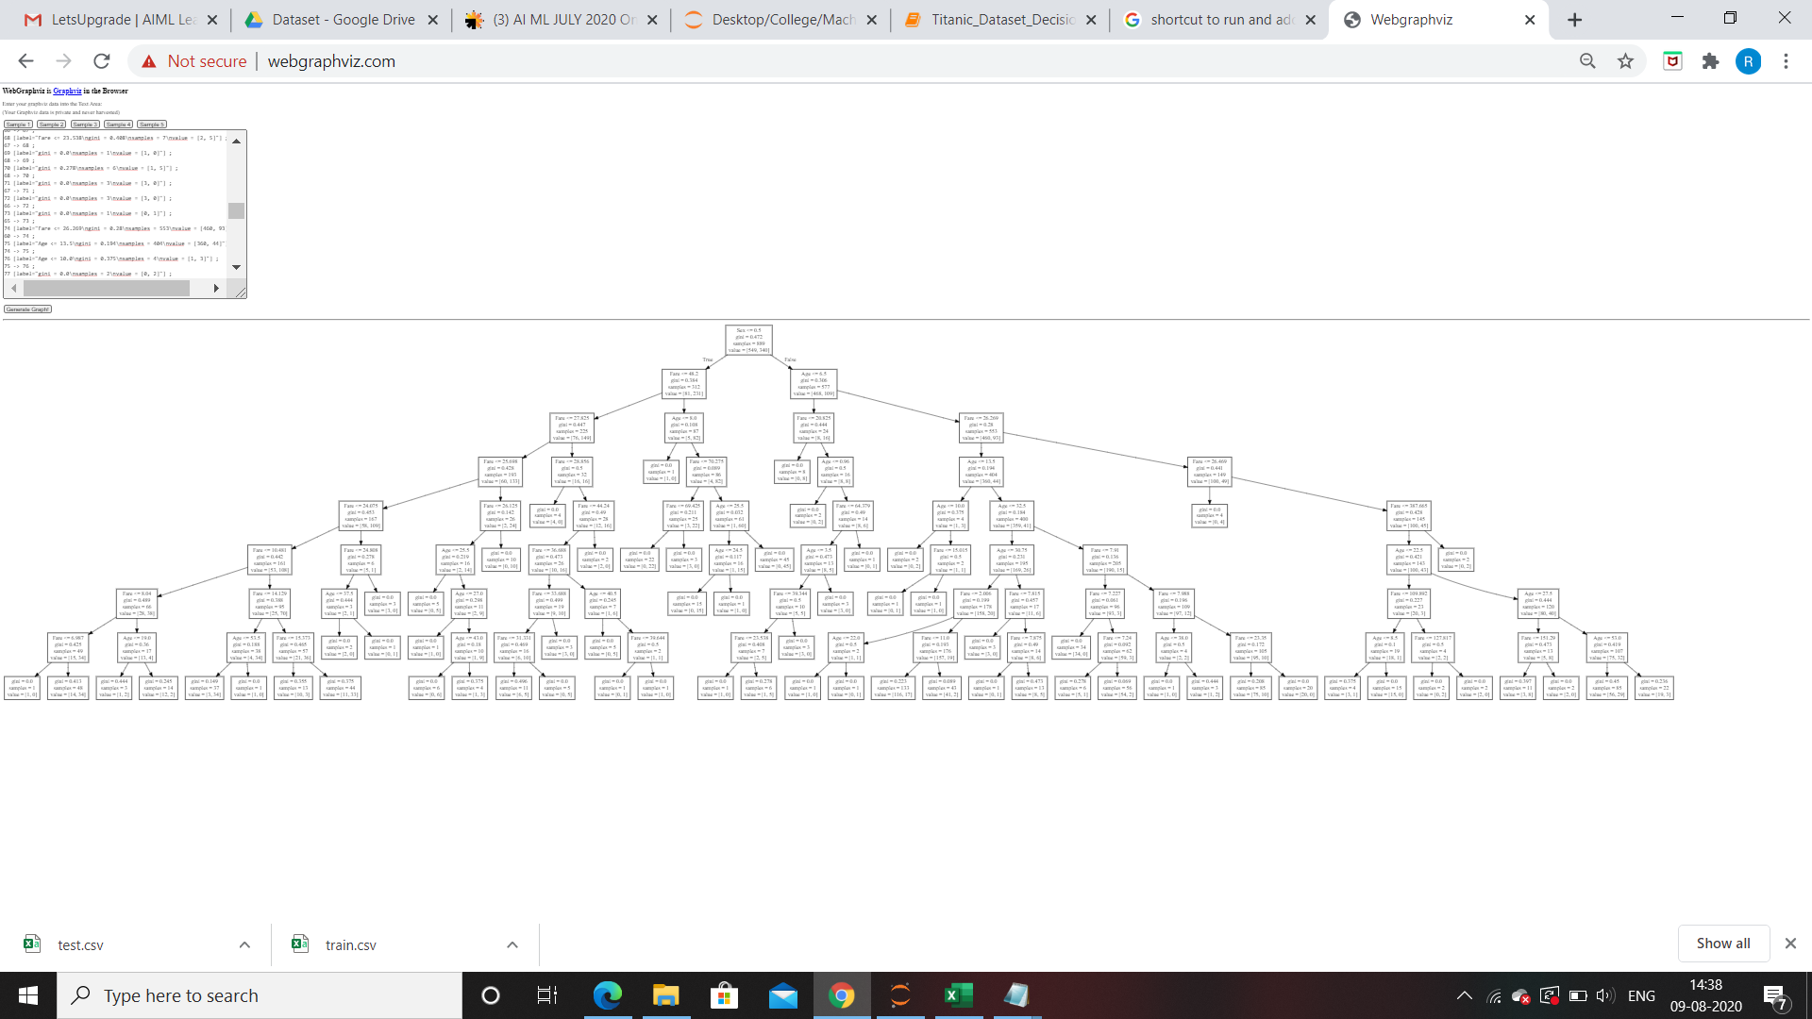

Project-2

(Attrition Dataset Decision Tree)

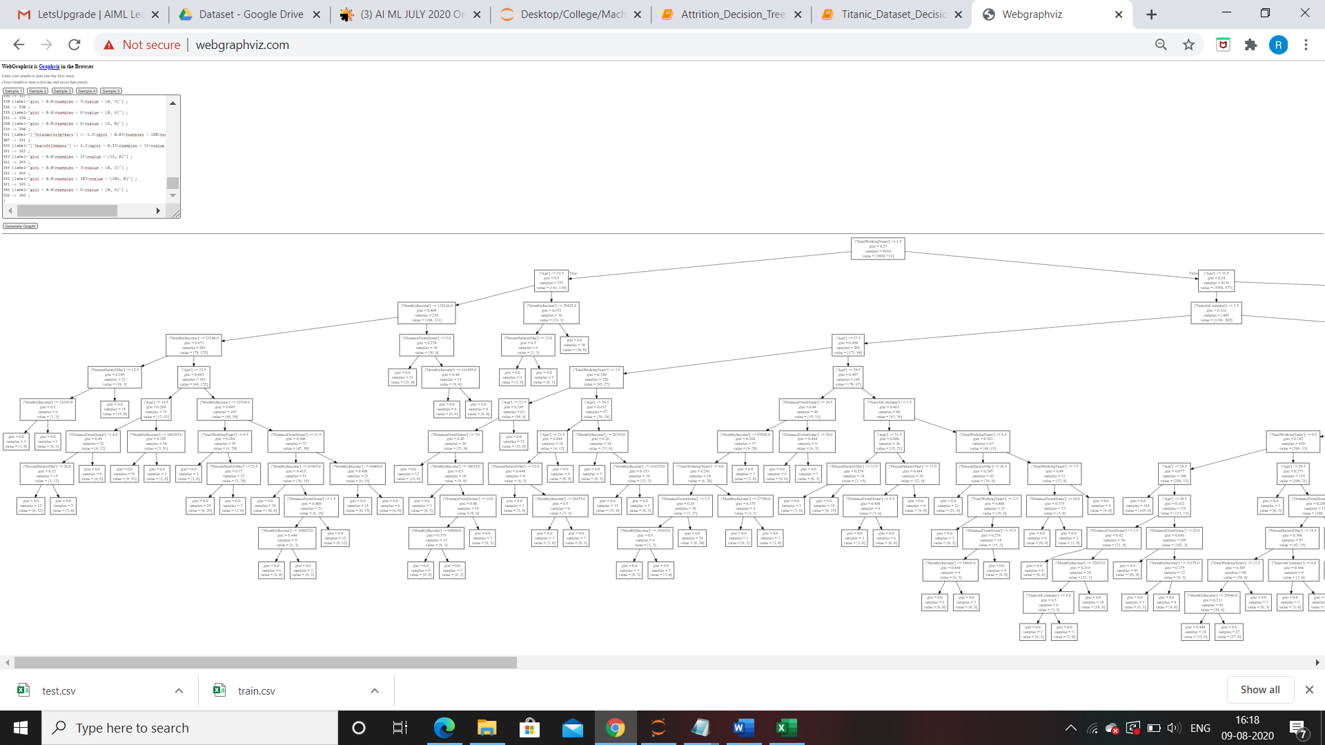

Project-3

(Bank Loan Decision Tree)

